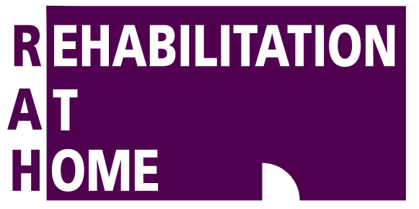

**Strains vs. Sprains**

**Strains and sprains are words that are used almost interchangeably when describing injuries, however they each actually have quite distinct meanings. The most straightforward explanation is that a “strain” refers to a tear in a muscle or tendon, while a “sprain” refers to a tear in ligament fibers. Below we briefly describe what that means and how we treat sprains and strains differently.**

Ligaments are fibrous tissues that connect and hold bones to other bones. These are very strong parts of your anatomy and, depending on the joint, provide large amounts of support and stability to the body.

Some ligaments are so strong, for example in the shoulder, that sometimes a bone will break before the ligament will tear. When ligament fibers do tear, the nearby joint can actually feel unstable.

Ligament tears will usually swell up and have a normal inflammatory reaction. Pain will be worse with movement or if the ligament is placed under more stress. Occasionally, if a ligament has torn all the way through, there is much less pain than with a less severe injury.

Your physiotherapist is able to grade the severity of a ligament

sprain, which will help guide treatment and expected recovery times.

Muscle strains are easy to confuse with ligament sprains, however there are a few telltale differences. Following a muscle tear, it is more likely that you’ll feel weakness rather than instability. The pain will also be isolated over the muscle or tendon body. An injury to a ligament will be tender over the site of the ligament and special tests can be done to show a laxity due to the injury.

Treatment is also slightly different as sprains will need more support and will sometimes even need to be braced, whereas muscle strains will benefit from gentle movements earlier.

In both cases, following the basic principles of **rest**, **ice**, **compression** and **elevation** is great advice in the early stages of any injury. Heat is not recommended until at least two days after the injury.

**It is important to seek professional opinion when recovering from both a strain and a sprain. It is very easy to re-injure an area while it is healing if undertaking strenuous activity too early and without correct rehabilitation. Speak to your physiotherapist for more information.**

**PhysioTip**

In most cases you don’t need a GP referral to see a physiotherapist; you can make an appointment directly with the clinic.

FEBRUARY 2016

**Brain Teasers**

*Only one of these statements is true. Which one is it?*

1. One of these statements is false.

2. Two of these statements are false.

3. Three of these statements are false.

*What is the next number in this sequence?*

2, 5, 9, 14…..

*What does this say?*

Try Stand

2

Answers on the next page…

FOR

APPOINTMENTS

CALL

55 288 617

Physiotherapy Exercise Physiology Rehabilitation Nursing Services

LAKE COMO – ITALY

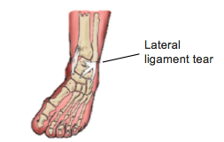

# **Ankle Sprains**

**Grilled Polenta with Rocket and Feta**

1. Place tomatoes onto a baking tray lined with foil and drizzle with olive oil. Bake in a preheated oven at 170 d Celsius for 1hr.
2. Bring water to the boil, reduce to low heat and slowly add polenta, stirring constantly for 6 minutes until polenta is smooth and thick, stir in Parmesan cheese.
3. Place polenta onto a chopping board and flatten to 1.5cm height. Place in fridge for 40 minutes to set. Cut into 6cm by 6cm squares and spray both sides with olive oil.
4. Heat a bbq hotplate and grill to medium heat, cook polenta pieces on each side for 2-3 minutes.
5. Wash rocket and place on top of baked polenta, cover with feta cheese and drizzle balsamic glaze over top to taste.

***Ingredients***

*2 cups instant polenta 5 cups water*

*100g parmesan cheese 200g crumbled feta cheese*

*2 cups of rocket lettuce 6 vine ripened tomatoes*

*3 Tbsp Olive oil.*

*Brain Teaser Answers: 1. The second statement 2. 20 (2+3=5,5+4+9,9+5=14,14+6=20) 3. Try to understand*

**Ankle sprains are extremely common, however, this doesn’t make them easy to cope with when they happen to you. If you’ve ever spent two weeks hobbling around on crutches after an unfortunate twist, you’ll understand just how painful and difficult they can be.**

**What are they?**

Ankle sprains refer to a tear to the ligament fibres of the ankle. Commonly, a person will roll their ankle inwards and tear the ligament on the outside. Occasionally, the ankle will twist outwards and the ligaments on the inside of the ankle are torn and even less commonly, the fibres of the ligament that hold the two bones of the lower leg together tear (high ankle sprain). A sprained ankle will usually be painful, swollen, bruised, difficult to walk on and in some cases unstable.

**How does it happen?**

Ankle sprains can occur from something as simple as putting weight onto your leg when you think your foot is flat even though it’s not. The most typical pattern is of a person jumping

and landing on the outside of their foot or simply slipping and twisting their ankle. A sprained or twisted ankle is one of the most common injuries presented to emergency departments around the world. This is important as a severely sprained ankle can actually have very similar symptoms to a broken ankle and will need an X-ray.

A medical professional should assess any severe sprain. However, there are some guidelines to help decide if a sprained ankle needs X-ray.

1. You are unable to put weight on the ankle immediately after the injury.
2. You are unable to take more than 4 steps immediately after the injury.
3. Pain on the bony edges of the outer foot and ankle.

**How long do sprains take to heal?**

Depending on the severity of the tear, from one to six weeks. Your physiotherapist is able to help with recovery and ensure nothing slows down the healing. Following any injury of the body, joints may remain a little

stiff and lose strength and control. Even though the injured tissues have healed, the ankle doesn’t move quite the way it used to. This means that your risk of twisting it again is higher than before the injury.

**How can physiotherapy help?**

Correct rehabilitation can help to prevent recurring injuries. As well as providing support to the unstable ankle, your physiotherapist will help you to strengthen any weak muscles and restore balance and control through exercise. They are also able to correct any abnormal movement of the joint following swelling.

**The information in this newsletter is not a replacement for proper medical advice. Always see a medical professional for assessment of your individual condition.**

Focus On…

**DID YOU KNOW?**

The correct anatomical name for the kneecap is the patella, for the shoulder blade it is the scapula, and for the collarbone it is the clavicle. These are useful things to know as they often pop up on quiz nights!

Psychology Podiatry Dietitian Diabetic Educator Registered Nurse Services

2/100 Cheltenham Dr

Robina, QLD 4226

(07) 5528 8617

www.rehabilitationathome.com.au

2/100 Cheltenham Dr

Robina, QLD 4226

(07) 5528 8617

www.rehabilitationathome.com.au

2/100 Cheltenham Dr

Robina, QLD 4226

(07) 5528 8617

www.rehabilitationathome.com.au